[E136] Power cord

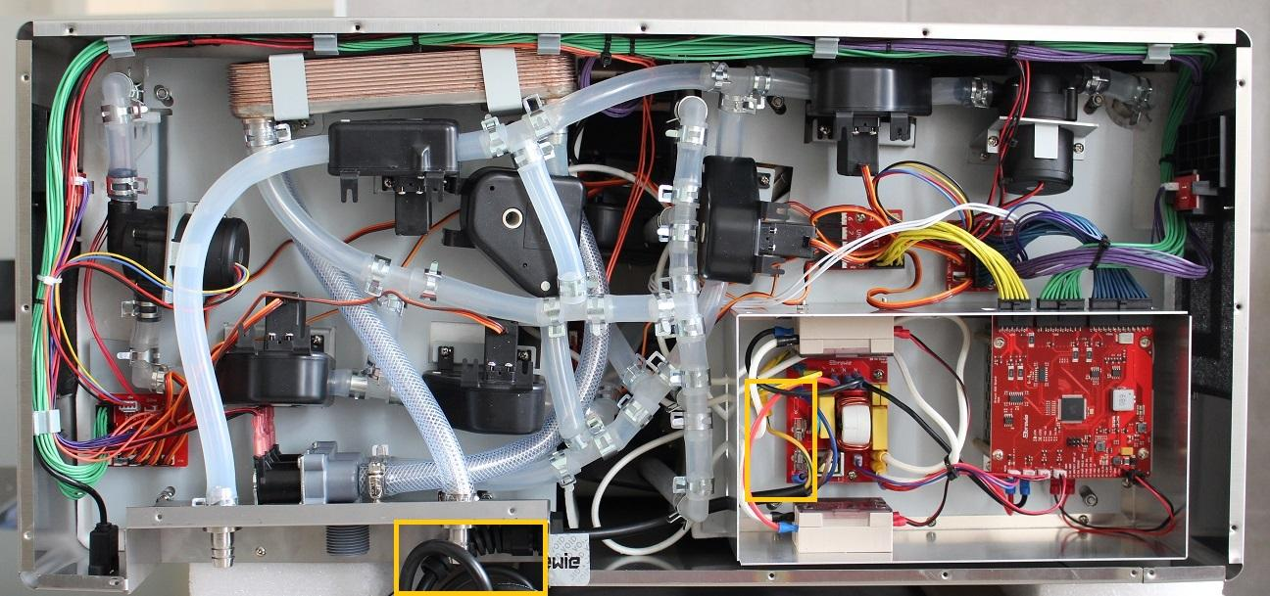

Unscrew the strain relief lock nut inside the machine on the rear plate.

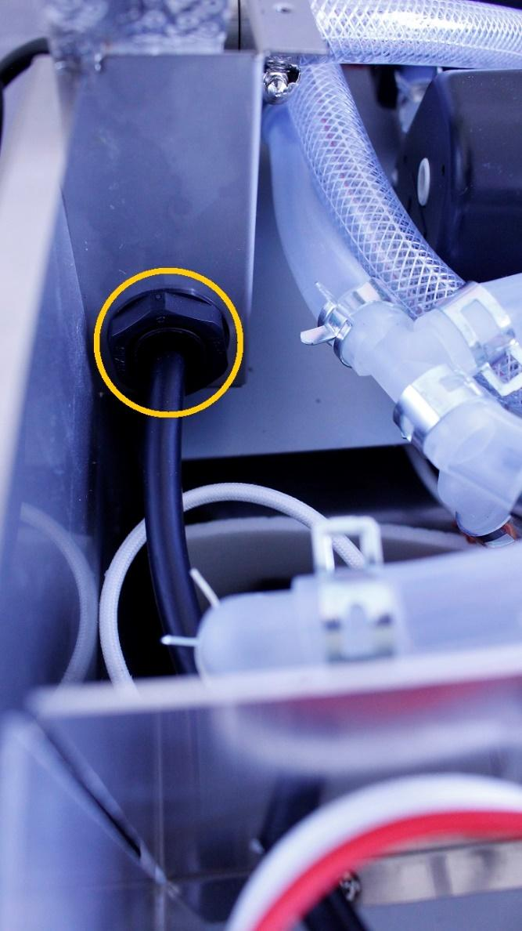

Disconnect the indicated plugs from the high voltage panel.

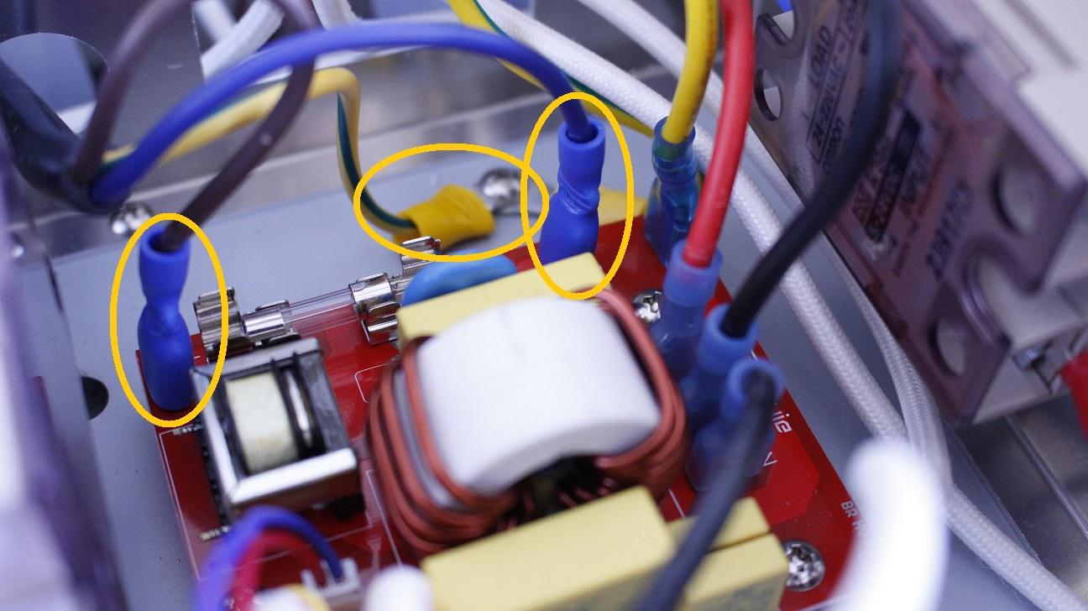

The cable can be removed now.

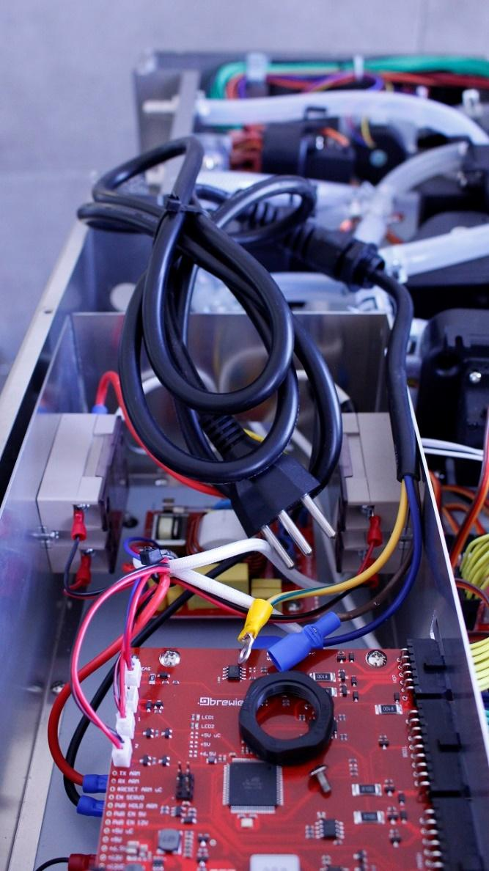

Reassembling consists of the same steps in reverse.